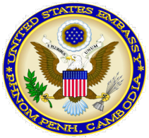

American Corner
Cambodia
Joint project of Management and Economics University and U.S. Embassy Phnom Penh

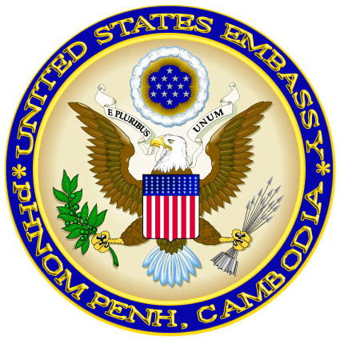
Report
April, 2014
March 26th-April 25th 2014
Kampong Cham, Cambodia

- Statistics
  - Total American Corner’s patrons 510 patrons (UME: 399, Public: 111 )
- Number of patrons using Internet:429 patrons
- Number of patrons using AC’s material except Internet 81 patrons
  - Number of books were used 79 books
  - Number of magazines were used: 22 magazines
  - Number of books were checked out: 11 books
  - Number of books were checked in:14 books

II Programs

- April 22nd 2014: Earth Day celebration was presented by Shorn Ron, Deputy director of UME. There were 36 UME students to attend this event.
- Literature club was closed
Reported by
American Corner Coordinator
Seen and approved
Director of UME

